# **Lyrics Extractor GUI**

## **Overview:**

The Lyrics Extractor GUI Application is a Python-based graphical user interface program designed to fetch and display lyrics of songs. It integrates web scraping techniques to extract lyrics from online sources and presents them in a user-friendly interface.

## **Features:**

* Simple and intuitive user interface.
* Allows users to input the title and artist name of a song.
* Fetches the lyrics of the specified song from online sources.
* Displays the lyrics in a text area within the application window.
* Provides error messages for cases where the lyrics are not found or if the input fields are empty.

## **Requirements:**

* Python (3.x recommended)
* Tkinter library (usually comes pre-installed with Python)
* Requests library (pip install requests)
* Beautiful Soup library (pip install beautifulsoup4)

## **Execution Steps:**

### **Step 1: Clone the Repository**

Clone the repository containing the Registration Form Application code from the GitHub repository:  
  
git clone <https://github.com/your_username/lyrics_extractor.git>

**Step 2: Navigate to the Project Directory**

Navigate to the directory where the project files are located:

cd lyrics_extractor

### **Step 3: Install Dependencies (if necessary)**

Ensure you have Python and Tkinter installed on your system. If not, install them using the following commands:

Install Python (if not already installed)

* **For Linux:**  
  sudo apt-get update  
  sudo apt-get install python3
* **For macOS:**  
  brew install python3
* **For Windows:**  
  Download Python installer from <https://www.python.org/downloads/>**# Install Tkinter**  
  # Tkinter usually comes pre-installed with Python. If not, install it using the package manager specific to your operating system.

### **Step 4: Run the Application** Navigate to the file path – cd path

Run the Python script **‘python** **registration_form.py’** using the following command:

python lyrics_extractor.py

**Step 5: Input Song Details**

Once the application window opens, enter the title and artist name of the song for which you want to fetch the lyrics.

**Step 6: Submit the Form**

Click on the "Search" button to fetch the lyrics of the specified song. The lyrics will be displayed in the text area within the application window.

**Screen Shorts:**

**Lyrics Extractor GUI:**

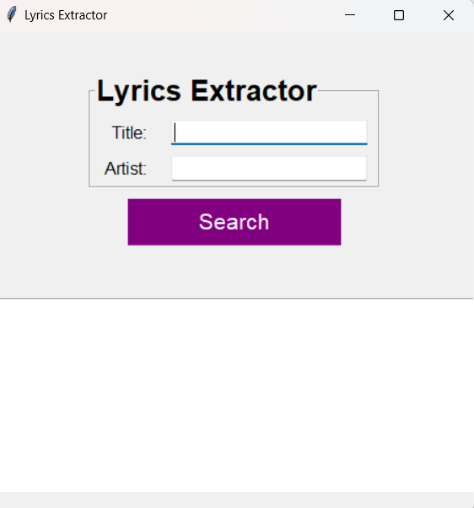

**Validation of Fields:**

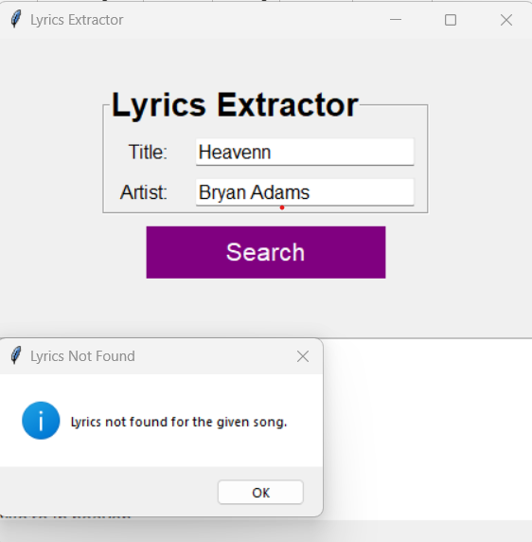

**Successful Extraction of Lyrics :**

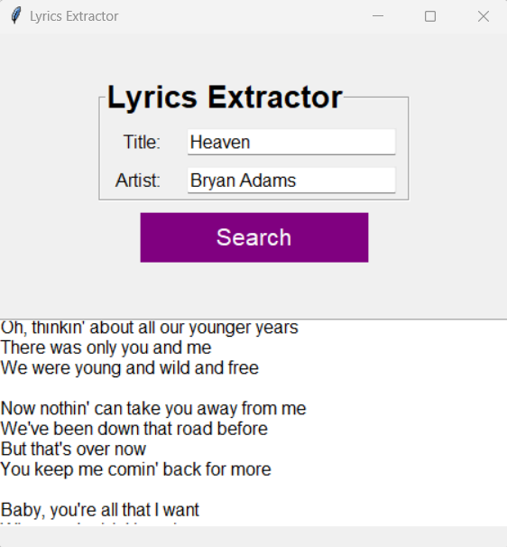

**Support and Feedback:**

For any issues or feedback regarding the Lyrics Extractor GUI Application, please contact

**Email:213h1a0511@klmcew.ac.in**